Help Veer Now - Corporate Supporter Pack
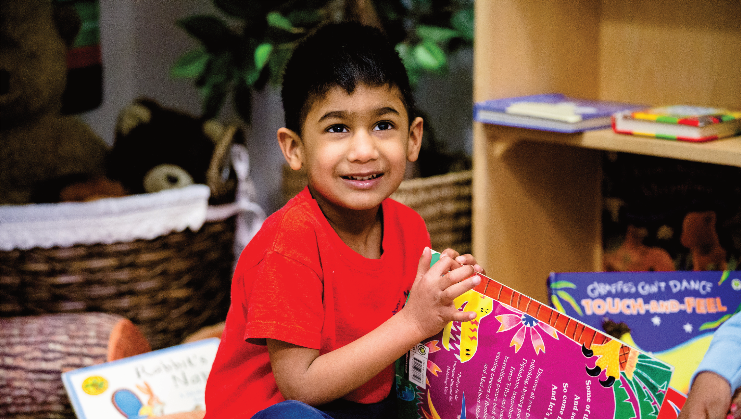
This is Veer, a 4 year old cheeky-boy who’s been diagnosed with a very rare and life limiting genetic disorder called Fanconi Anaemia. The bone marrow failure caused by this disease (inability to produce blood cells) means that patients have an increased chance of developing some form of blood cancer or tumours of the head, neck or skin.
In order to give Veer, the very best chance of survival, he requires a stem cell transplant. For the best chance of success, Veer needs to find a donor who can be a perfect stem cell match for him and he needs to find one soon.
Currently, there are no perfect matches on the national or International registers for Veer and given that the family have just received the shocking news that Veer may require a transplant in the next few months; a timeframe which his doctors had originally estimated to be years away. Therefore I am making this URGENT appeal to you all.
3 simple ways in which you can help
Idea No. 3
Share our story online
Share our story with your customers & suppliers and encourage them to join in your campaign.
Idea No. 2
Share Veer’s story with your staff
Many of our supporters have shared our story on their regular staff communications to encourage staff to register. Staff around the world can join the campaign.
Idea No. 1
Run a donor drive in 3 easy steps
1. Invite your employees to request a swab kit
2. Setup a team meeting so they can all swab together
3. Get them to return their kits straight way
We’re supporting Veer’s campaign to help him find a donor.
Please register as a donor today!
Veer’s story
This is Veer, a cheeky 4 year old who’s been diagnosed with a very rare and life limiting genetic disorder called Fanconi Anaemia. The bone marrow failure caused by this disease (inability to produce blood cells) means that patients have an increased chance of developing some form of blood cancer or tumours of the head, neck or skin.
In order to give Veer the very best chance of survival he urgently needs to find a donor who can be a perfect stem cell match for him and he needs to find within just a few months.
The process of registering as a donor is really simple:
1) Register to donate stem cells at helpveernow.org/register
2) You will receive a kit that requires a simple cheek swab from the comfort of your own home and then returned to the charity (DKMS or Anthony Nolan)
3) If you get the opportunity to be the lifesaver of someone like Veer the procedure is in most cases very simple and can make the difference of life and death to the patient. Further details can be found at https://www.dkms.org.uk/en/registration-donation-process-explained
Register |  | Information
We’re planning a corporate swab day on _______________________

